Template FIA Drifting Sporting Regulations

Introduction 3
General information 3

COMPETITION DIVISIONS
1. Competition participants 3
2. DRIFT 3
2.1 DC3 4
2.2 DC2 4
2.3 DC1 4
3. ENTRY PROCEDURE 4

COMPETITION OFFICIALS
4. COMPETITION Officials 4
4.1 Steward 5
4.2 Clerk of the Course AND/OR Race Director 5
4.3 EVENT secretary 5
4.4 Technical delegate AND/OR CHIEF SCRUTINEER 6
4.5 Judges 6

PENALTIES
5. Penalties 7

GENERAL PROVISIONS
6. General provisions 7
7. Competition numbers and advertising on cars 7
7.1 COMPETITION NUMBERS 7
7.2 ADVERTISING ON CARS 10
8. Safety 10
8.1 GENERAL SAFETY 10
8.2 TRACK CONTROL 10
9. Insurance 11
10. Signalization 11
11. Administrative check 11
12. SCRUTINEERING 12

COMPETITION
13. Briefing 12
14. PRACTICE 11
15. COMPETITION 13
16. START LINE PROCEDURE 13
17. Finish line procedure 14
18. Qualification 14
18.1 QUALIFYING FORMAT 14
18.2 INITIATION DURING QUALIFYING 14
18.3 QUALIFYING SCORING 15
18.4 QUALIFYING JUDGING CRITERIA 15
18.5 force majeure 18
19. TANDEM Battles 18
19.1 ELIMINATION FORMAT 18
19.2 TANDEM JUDGING CRITERIA 19
19.3 INCOMPLETE TANDEM RUNS 20
19.4 PASSING 21
19.5 TANDEM INITIATION PROCEDURE 21
19.6 TANDEM COLLISIONS AND CONTACT 22
19.7 CAR SERVICE DURING TANDEM 23
19.8 TANDEM REPLAYS AND TELEMETRY 23
20. COMPETITION TIMEOUT 23
21. Tandem battle start procedure 24
  - Before the first run of a tandem battles 24
21.2 Between tandem battle runs 25
22. Competition classification 25
23. COMPETITION POINT SYStem 25
23.1 Top 32 25
23.2 TOP 24 26
23.3 TOP 16 26
23.4 END OF SEASON TIE BREAKERS 26

PROTESTS AND APPEALS
24. Protest 26
24.1 FILING A PROTEST 27
24.2 PROTEST FEE 27
24.3 REVIEWING PROTESTS 27
25. APPEALS 27

GENERAL Code of Conduct and Behavior
26. Disclaimer 27
27. MEDIA Accreditation 27
28. Code of Conduct and Behavior 28

APPENDIX 1 – BRACKET TEMPLATES 29

APPENDIX 2 – GLOSSARY OF TERMS 31

Template FIA Drifting Sporting Regulations

INTRODUCTION
These Sporting Regulations have been drafted by the FIA Drifting Commission and follow the FIA Guidelines for Drifting Events. These Sporting Regulations are for the benefit of Competition organisers worldwide and serve as a template that can be adapted for use in both National and International competitions.

GENERAL INFORMATION

International competitions should be organized in accordance with the FIA International Sporting Code and the National Sporting Code of the ASN governing the competition. National competitions should be organized in accordance with the National Sporting Code of the ASN governing the competition.
The FIA Drifting Sporting Regulations are a document which sets forth the principles that govern drift competitions. The Organiser shall be responsible for conducting the competitions in accordance with the provisions set out in these Regulations.
Drifting is a scored competition in which cars compete by performing controlled slides of the rear-axle on a defined track (racetrack, closed road, or marked track); drivers should prevent the interruption of rear-axle slides of the car by spinning or straightening of the car (rear axle is following front axle). Only rear-wheel drive cars can participate. Generally, each competition will comprise of three stages:
- Practice,
- Qualification (Solo Runs), and,
- Battles (Tandem Runs).

COMPETITION DIVISIONS

- Competition participants

The competitor is always a driver with a car and possibly another registered person authorized to act on their behalf.

However, the team members must appoint a person to act as a team representative (Driver, Team manager, Spotter). The team acts solely through a team representative who officially represents the team, can protest and can opt out the team from the competition, or even from the championship. It is permitted to replace the team representative. If a team representative is replaced during the competition, it is the drivers responsibility to report the change to the event secretary. Replacement of the team representative is only affective following a formal notification of this change to the event secretary.

- COMPETITION CATEGORY

Driving with a controlled slide on the marked track, judged by judges. Only rear wheel driven cars can participate those competitions. Drift is divided in to 3 categories: DC1, DC2, DC3.

  - DRIFT CATEGORY DC3

Designed for complete beginners or intermediate drivers, category DC3 is for those with little or no experience in drift competitions. The cars must comply with the current technical regulations for the DC3 category. All drivers must hold an appropriate competition licence issued through their local ASN, according to the ASNs specific requirements.

  - DRIFT CATEGORY DC2

The DC2 category is intended for drivers with a sufficient level of drift experience. The cars must comply with the current technical regulations for the DC2 category. All drivers must hold an appropriate competition licence issued through their local ASN, according to the ASNs specific requirements.

DC2 competitions should take place on a course with a lower overall speed than would be used for the DC1 category.

  - DRIFT CATEGORY DC1

The DC1 category is positioned as the premier level of drift competition and is for drivers with an appropriate level of Skill and Experience. All cars must comply with FIA DC1 Technical Regulations. All drivers must hold an appropriate competition licence issued through their local ASN, according to the ASNs specific requirements.

All International competitions will follow DC1 Regulations.

- ENTRY PROCEDURE

Competitors should register for the competition in advance and in compliance with the procedure outlined by the individual organiser. Competitors wishing to enter the competition after the deadline has passed may be permitted to do so at the organisers discretion and may be subject to a higher fee.

Only entries accompanied by a completed and signed form, valid competition licence and entry fee will be accepted. The organiser reserves the right to refuse the entry of any competitor stating the grounds for such a refusal.

Should an entered competitor fail to attend the event, it will be at the organisers discretion whether to return any entry fee or whether to accept their entry at future events.

The organizer reserves the right to limit the total number of entries accepted for each competition.

COMPETITION OFFICIALS

- COMPETITION Officials

The competition officials are appointed by the organizer in consultation with the ASN and/or FIA. Officials must declare any conflicts of interests that may prejudice the performing of their roles.

All officials shall conduct themselves according to the highest standards of behaviour and failure to do so may result in loss of appointment for the event or revoking of their licence.

The following roles must be appointed and named in the specific event regulations:

- Steward(s),
- Clerk of the Course and/or Race Director,
- Event Secretary,
- Chief Scrutineer and/or Technical Delegate, and,
- Judges.

  - Steward(S)

The Steward(s) must be in close contact with the Clerk of the Course for the duration of the event in order to ensure the proper running of competition. The Stewards are appointed by the FIA and/or ASN under whose jurisdiction the competition is organised. The Stewards have the absolute power to ensure compliance with all appropriate regulations and procedures, and report only to the applicable courts.

The responsibilities of the Stewards will include (but are not limited to):

- Approving any changes to the event regulations through issuing a Bulletin,
- Considering any matter referred to them by the Clerk of the Course, Race Director, Judges or Chief Scrutineer and/or technical Delegate and imposing penalties, up to and including disqualification, as required,
- Postponing or suspending a competition in case of force majeure or serious safety reasons, on recommendation of the Clerk or the Course and/or Race Director,
- Approving any changes to the competition timetable, and,
- Approving the final results of the competition.

  - Clerk of the Course AND/OR Race Director

The Clerk of the Course will be responsible for ensuring the competition is organised and run to a safe standard and in conformity with the competition regulations. If the event is a single round of a Series Cup or Championship, A Race Director may be appointed to work alongside the Clerk of the Course to ensure that similar standards and procedures are followed across all Series, Cup or Championship events.

Competitors must follow all instructions from the Clerk of the Course and/or Race Director.

The responsibilities of the Clerk of the Course and/or Race Director will include (but are not limited to):

- Ensuring that all officials and assets are in position and that the racetrack is safe and ready for competition,
- Liaising with the relevant local authorities to ensure a safe, regulated event, and,
- Keeping the competition on schedule according to the published timetable.

  - EVENT secretary

The Event Secretary is responsible for all event documentation, including competitor information, ASN regulations and official results. It is the responsibility of the Event Secretary to ensure that the event is permitted to take place by the local government, ASN and FIA, and that each competitor is permitted to take part.

  - CHIEF SCRUTINEER and/OR Technical delegate

The Chief Scrutineer examines the competition cars and the drivers’ personal protective equipment, in order to ensure their conformity with the regulations.

A Technical Delegate may be appointed who will supervise and assist the work of the Chief Scrutineer and have full authority over the national scrutineers. If appointed, the Technical Delegate is responsible for all technical matters, including scrutineering.

The responsibilities of the Chief Scrutineer will include (but are not limited to):

- conducting checks prior to the start of the event on all entered cars to ensure that they are safe for competition in compliance with the appropriate Regulations and entered into the correct competition category,
- monitoring the condition, providing reports and advice on all cars involved in accidents, including assessing their suitability to resume competition activity, and,
- ensuring that all competitors correctly wear or use their required personal safety equipment, including gloves, boots, fireproof undergarments, race suit, helmet and Frontal Head Restraint, as required in the Regulations.

  - Judges

The judging panel consists of three judges, one of whom is appointed as Head Judge, specifically named in the Special Provisions for each Sporting Event. The Head Judge is responsible for the driver's assessment protocols and maintains communication with the Clerk of the Course, Race Director and Stewards throughout the event. During qualifying, the Judges will independently assess each competitor’s qualifying runs using individual criteria, which are then added together for a possible total of 100 points.

During the tandem battle portion of the competition, the judges will independently determine a winner by comparing the lead runs of both drivers, as well as the chase runs of both drivers during each battle. Judges can use video replays or any other measuring tools to help them reach a decision and are considered as a Judge of Fact. In the case of significant changes in the driving conditions, the Judges may recommend changes to the layout to the Clerk of the Course, for approval by the stewards.

The judging criteria for qualifying will be a combination of the following:

- Speed,
- Angle of drift,
- Line (line is designated by clipping points, outside zones and touch & go areas), and,
- Style.

The judging criteria for tandem competition are:

- Lead driver’s line, angle and style,
- Chase driver’s ability to mirror the lead driver’s line, angle, speed and style, and,
- Chase driver’s proximity to the lead driver.

Judges responsibilities shall include:

- Determining the course layout before the competition, in cooperation with the Clerk of the Course and/or Race Director,
- Providing exact feedback to the Competitors throughout the competition,
- Determining responsibility for any contact/incidents on track. Beyond this, if further action is required, the Judges can refer the matter for the consideration of the Stewards, and,
- Analysing specific complaints or queries.

PENALTIES

- Penalties

Any violation of these regulations or the applicable Sporting Code may result in the competitor being referred to the Stewards, who have the right to investigate and penalise as required.

The following Penalties may be applied by the competition stewards:

- Reprimand,
- Fine, or,
- Disqualification.

Any fine must be paid by the deadline stated in the decision.

GENERAL PROVISIONS

- General provisions

As per Article 12, it is within the rights of the Chief Scrutineer and/or the Technical Delegate to not permit a car to take part in a competition should it be deemed as unfit or dangerous. During the whole competition, the car must be in complete shape (including bumpers, bonnets, doors and other parts). Exception may be granted in the event of an accident, at the discretion of the Chief Scrutineer and/or Technical Delegate. No liquids may be leaking from the car.

- Competition numbers and advertising on cars

  - Competition numbers

    - The competitors shall have the right to select their starting number (ranging from 2 to 999) by making a request to the organisers. Numbers will be assigned on a first come first served basis. #1 will be reserved for any reigning champion who may use that or select another (if available).

If a request is not received from the competitor, their number will be assigned by the organisers.

    - Competitor numbers should be placed the roof and both sides of each car, with exact location and size to be determined by the event organiser.

    - Placing any other labels or stickers on the front window, apart from any supplied by the organisers, is strictly forbidden.

    - The Organiser shall have the right to oblige the competitors to place additional advertisements on their cars, with the exact locations to be specified in the Regulations.

    - Competitors are obliged to place their surnames and national flag, below their windows on both side doors.

    - The location of all car markings should be as recommended below:
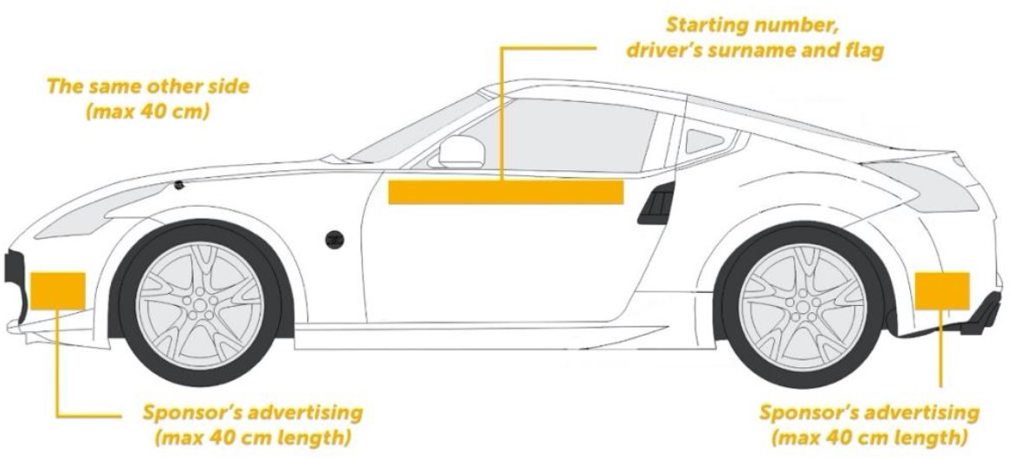
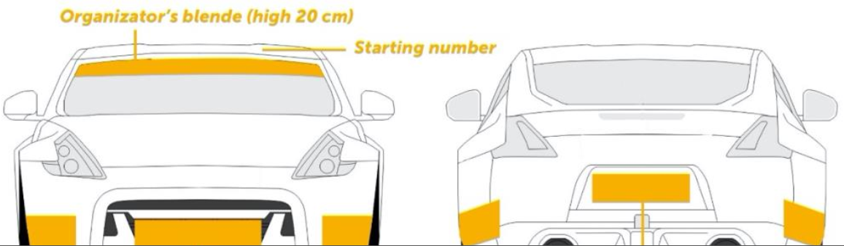
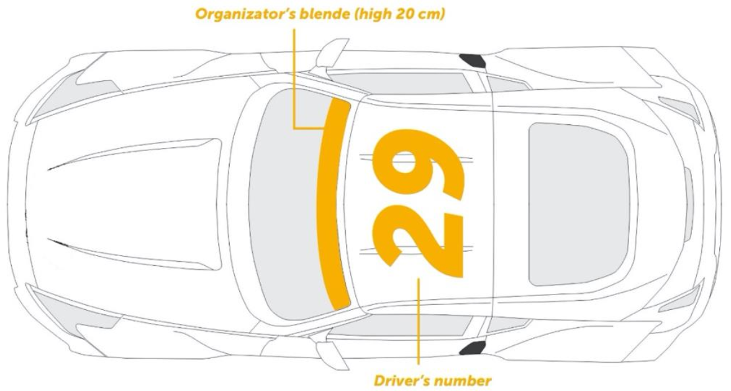

  - advertising on cars

All advertising on cars should not obstruct the drivers vision.

All advertising displayed on cars must be in compliance with the FIA International Sporting Code and the respective National Sporting Code and applicable advertising laws of the host nation.

- Safety

  - GENERAL Safety

Should any car have a technical failure on the track during a competition or practice, it must be removed from the track as quickly as possible so that its presence does not interfere with the competition.

It is strictly forbidden for drivers to drive in the opposite direction of the competition, unless it is approved by the Clerk of the Course and/or Race Director as necessary for the car to be removed from a dangerous position.

The car will be recovered from the track only by event officials and only after it has first come to a stop. Team members may be permitted to access the track and assist with the recovery only at the express permission of the Clerk of the Course and/or Race Director, however, they are not permitted to conduct repairs to the car on the track, only assist in the cars immediate removal. Except in case of fire, the driver should remain inside the car to assist with its recovery. During practice and competition, drivers may only use the designated track and must always observe the rules of the Track regarding driving behaviour.

In a collision, breakdown, or other incident on the track, the track marshals will display a red flags, which they can each deploy at their discretion when required. Should a red flag be displayed, the drivers must immediately slow down, stop drifting and proceed to the end of the track if safe to do so. In the event of a serious accident, the Clerk of the Course and/or Race Director or the Chief Medical Officer may instruct the driver to undergo a medical observation or examination. In this case, a driver may not re-join the competition until cleared to do so by the Chief Medical Officer.

The Clerk of the Course and/or Race Director may instruct a driver or his team to undergo an Anti-Alcohol test or a test for addictive substances at any point during the event.

Following an accident, the Chief Scrutineer and/or Technical Delegate may check a car to determine if it remains safe and fit for competition.

Refuelling of a car is only permitted in the designated refuelling area and must be performed with the utmost care. An additional team member equipped with a minimum 6kg handheld fire extinguisher must be present throughout the refuelling process.

  - TRACK CONTROL

The Clerk of the Course and/or Race Director and the Head Judge must inspect the course before the start of Practice and again before the start of both qualifying and the tandem battles begins.

It is the Clerk of the Course’s responsibility to ensure that the track is safe and ready for competition.

- Insurance

Each competitor should have his or her own personal injury insurance suitable for motorsport. The Organisers are not financially responsible for damage to the car, medical costs of competitors, or damage or loss to any equipment or infrastructure, except in cases where it is the result of negligence on the side of the organisers.

Organisers must have adequate Public Liability Event insurance in place that conforms with the requirements of the host ASN and FIA (when appropriate).

- Signalization

In drifting, only two flags and/or light panels (if available) should be used to signal to drivers and officials on track:

- Red flag – cancelation of the run due to a hazard on track. Immediately decrease speed, continue to the finish area if safe to do so or stop on the track if requested to do so by an official.
- Green flag – used to indicate that the track is clear of obstacles and ready for competition.

Should a competitor ignore the instructions given by an official’s flag or light panel, the Clerk of the Course may refer the matter to the Stewards.

- Administrative check

Prior to the start of a competition, each Competitor must have provided the organiser with at least the following:

- their original Competition Driver’s Licence, including a letter of authorisation for foreign events if they are competing abroad,
- their Team Licence, if appropriate,
- a completed Entry Form and evidence that they have paid the necessary Entry Fee for that Competition, and,
- any other specific documentation that has been requested by the Organiser, Host ASN or the FIA.

Failure to produce all the required documentation will result in the refusal to let the competitor take part in the competition and possible forfeiture of any paid fees, at the organiser’s discretion.

- SCRUTINEERING

At a time and place and in a manner determined by the Chief Scrutineer / Technical Delegate, and prior to the start of competition, all cars and driver safety equipment must undergo scrutineering.

Furthermore, every car remains subject to further technical inspections at any time before, during or after an event, at the time and in the place and manner directed by the Technical Delegate or the Stewards of the Event.

By entering the competition, the competitor certifies that:

- his or her car and personal protective equipment will remain in good condition and the same as stated on the Scrutineering check list throughout the entire event,
- the competitor will in fact use all safety and personal protective equipment noted on the Scrutineering check list and as required by the Regulations, and,
- if anything changes from what is stated on the Scrutineering check list, the competitor will immediately notify the Technical Officials of the event.

Falsifying a Scrutineering check list or failing to comply with the Regulations may subject competitors to disciplinary action as determined by the Stewards, up to and including disqualification from the event.

If required, Technical Officials may at any time inspect, seal for inspection, download specific stored data and/or tear down a participant’s car.

Failure to comply in full with any inspection request may subject competitors to disciplinary action as determined by the Stewards, up to and including disqualification from the event.

All determinations by Technical Officials regarding the timing and method of technical inspection shall be final and not subject to appeal or review. Technical inspection assists Technical Officials with determining, in their judgment, eligibility for participation at an event.

The technical inspection does not in any way change the fact that the competitor, the crewmembers, and the car owner are ultimately responsible for the safety and operation of the car and equipment.

COMPETITION

- Briefing

The briefing is to be held on schedule and conducted in the appropriate language. Only the driver, their team manager and spotter should have access to the briefings. Attendance throughout the briefing is mandatory for all drivers during briefings pertaining to qualification and battles. The Head Judge and/or Clerk of the Course will lead the briefings. During the briefing, the drivers will be informed of any changes to the event's program and/or any changes to the Supplementary Regulations. The judges will define the ideal line, in particular the placement of clipping points and clipping zones.

Any driver who fails to attend a briefing without prior permission and sufficient reason, will be referred to the Stewards and may be subject to penalisation.

- PRACTICE

Drivers are to start each practice session only when permitted to do so by the start marshal. The maximum number of cars on track (i.e. between the start line and the finish point) is four during practice. In the case of a track that returns upon itself, the maximum number of cars on the track at one time would be two during practice. Participation in practice is not compulsory.

At the discretion of the organisers, a system to control the number of lead runs and chase runs will be applied by the start marshal with the aim to provide equal number of lead runs and chase runs for each car.

After the start of the competition, it is strictly forbidden to practice on the track outside the time of official practice sessions, as determined by the event timetable. It is also strictly forbidden to practice at other areas of the facility outside of the track during the competition period. Failure to adhere to these regulations will result in the competitor being referred to the Stewards.

- ComPETITION

The competition must be held on a track with at least four turns and must contain at least three scoring points (clipping zones and/or clipping points). The track length must be at least 400m and the track width must allow for tandem battles. Following practice, the competition will be divided into two sections - Qualification and Tandem Battles (using a bracket determined by the organisers).

Drivers competing in the DC3 category may only participate in qualifying, which will determine their final results.

If the Tandem Battle section of the competition cannot be completed for any reason, the qualification results will be used as the sole criterion for the overall driver ranking at that event.

- START LINE PROCEDURE

The start line is located at the beginning of the course and may be marked by an Arch. It is the official starting point of each qualifying run and tandem battle. There is a start light that is activated by the start line Marshal, which signals when the car(s) can leave the start line. During both qualifying and tandem battles, there may be a cone chicane, as illustrated in Figure 1, which is designed to decrease the acceleration of the lead car, permitting the chase car to maintain proximity down the straight away leading up to the initiation point. If the lead driver hits one or more cones within the chicane during a tandem battle, the battle will be halted and restarted, communicated either via a marshal or light panel posted trackside prior to the initiation point.

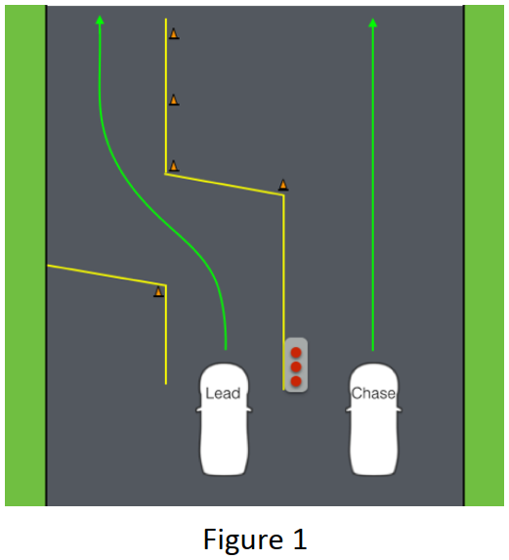
The lead car must start within two (2) seconds after the start marshal signals to do so, either through a flag or a light. If the lead car starts before the marshal signal, of after the two (2) seconds allowed, it will be noted by the Judges, and a restart may be ordered. Multiple such infractions possibly resulting in an incomplete being awarded for that run.

- Finish line procedure

The Driver must exit the judged track layout in a controlled way. The Judges will assess the Driver’s control of the car as it crosses the finish line. Should the Driver exit the judged course in an uncontrolled way, the Driver’s run will be judged as incomplete.

- Qualification

  - QUALIFYING FORMAT

Drivers will complete two non-consecutive runs on the course in reverse order of current rank in the Championship (Qualification at the first competition of the season, or a non-championship event, should be ascending according to the starting number).

If there is a technical defect on a car during the qualification, all results achieved up to the time of the defect are valid and scored. The driver is obliged to enter the qualification with the car in a condition in order to be able to pass the qualification run (tires, petrol, etc.). The repair of technical defects during qualifying is permitted, but only in the interval between the qualification runs. Tire changes and minor modifications/repairs between qualifying runs are permitted. The Driver must be prepared (dressed, fastened in the running car) for his qualifying runs at the moment when driver two places in front is starting (in the specified order). Driver is obliged to observe and follow the instructions of the start crew. If driver do not appear in time for the qualifying run, then he loses the qualifying round. The driver is obliged to continue in the competition with the same car he has qualified in.The best score of both qualification runs will be retained for the qualification ranking.

  - INITIATION during qualifying

During both qualifying and tandem battles, the car must be sideways as it passes the Initiation point, usually indicated by a marker such as a single standing cone in the “3, 2, 1” cone sequence placed trackside, as per Figure 2 below.

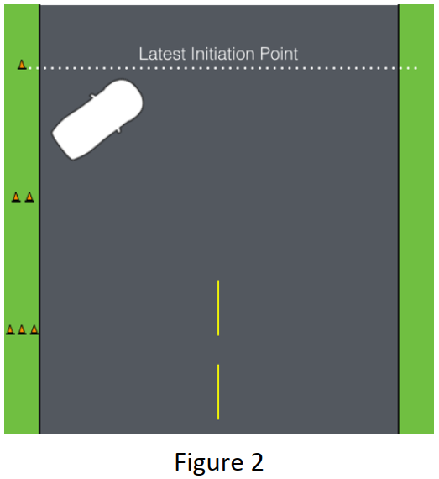

  - QUALIFYING SCORING

Qualifying scores will be awarded based on a combination of the four criteria below (allocated points are a recommendation):

- Line – 40pts
- Angle – 30pts
- Style (commitment and fluidity) – 20 pts
- Speed – 10pts

Judge 1 will be responsible for awarding the points for Line for each car. Judge 2 will be responsible for awarding the points for Angle of each car. Judge 3 will be responsible for awarding the points for both Style and Speed for each car.

The allocation of points shall be set before the Judges before the start of each event and may vary from event to event, but must always total to a maximum possible score of 100. Speed can only be used as a scoring criteria when there is an accurate method of measuring speed available.

  - QUALIFYING JUDGING CRITERIA

Drivers are expected to start with a committed, high angle initiation, drift through all of the outside zones and reach all of the inner clips with the maximum degree of angle and pace, while making quick, aggressive transitions with no corrections or mistakes.
Driving at the high difficulty level described by the judges, the driver is showing their level of car control.

Drivers that do not fill the outside zones, reach inner clips, or do so at a low degree of angle while making mistakes or corrections will receive deductions.

    - LINE

Drivers will be judged on their ability to adhere to the line stipulated by the line judge during the driver’s briefings. Points will be allocated to outside zones and inner clips, but may also be allocated to “touch & go” areas. Line points will be divided into by sectors (see Figure 3) at each track.

Line judge also gives deductions for wheels off the track:

One wheel off the track: | Two points deducted for each offence.
Two wheels off the track: | Five points deducted for each offence.
Three wheels off the track: | Ten points deducted for the first offence. If repeated during the same run, zero Line points will be awarded for that run.
Four wheel off the track: | Zero points

Further deduction examples:

- Missing zones & clips
- Partially filling zones
    - ANGLE

Drivers will be judged on their ability to achieve and maintain a high level of angle, as described by the angle judge during the driver’s briefings. Angle points will be divided into sectors (see Figure 3) at each track.

Deduction examples:

- Lack of angle
- Corrections
- Double initiation
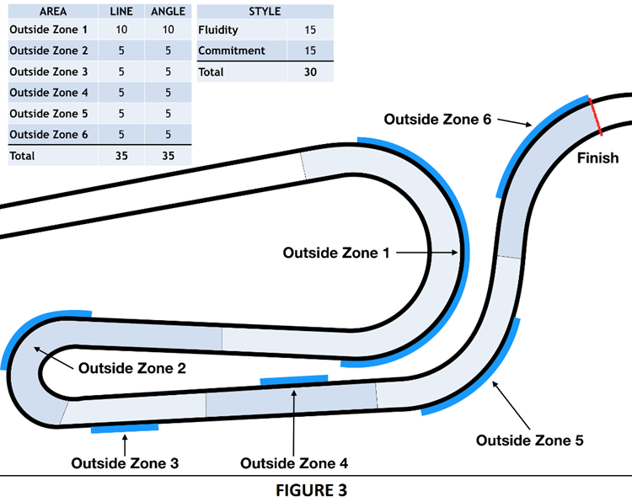

    - STYLE AND SPEED

Style is separated into two components; Commitment and Fluidity. Speed can also be separated into two components; initiation speed and average speed throughout the run.

Commitment
- Consistent throttle application.
- Maintaining pace throughout - using momentum to fill zones and the width of the course.
- Make it look exciting - approach barriers and track edge with confidence.

Fluidity
- Smooth rotation during transition.
- Lock to lock angle.
- Car is settled and flows through the course smoothly.

Initiation Speed
- Half of speed points awarded for achieving the target initiation speed. This target is a minimum speed to be achieved to gain the initiation speed points. Drivers may go faster, but will not be awarded with additional points.

Average speed throughout the run
- Half of speed points awarded for achieving the target average speed throughout the run.
- Average speed will be measured from initiation to the finish line.
- When possible, average speed should only be calculated using telemetry from the car that can ensure the correct line was followed, and not simply from timekeeping between the Start and Finish of a run.

Deduction examples for Style or Speed:

- Off or partial throttle prior to initiation.
- Initiating beyond latest initiation point.
- Slowing outside deceleration zones (As per Figure 4).
- Timid approach to walls or course outlines.
- Slow rotations.
- Stepped rotations (controlling the steering wheel to add small amounts of angle at a time).
- Inaccurate rotations (achieving degree of angle, then adding or subtracting angle).

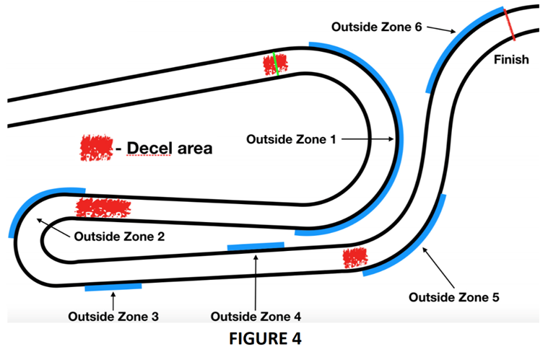
    - ZERO POINTS IN QUALIFICATION

Zero (0) points will be awarded for a qualification run if any of the following occur:

- A spin of a car between the start and end of a scored section of a track,
- Leaving a scored area of the track by all four wheels,
- Not initiating drift,
- Stopping car before finish line,
- Major straightening,
- Opposite drift (Drifting with the opposite angle required at that point on course), or,
- Hood and/or doors opening during a run. .

A Driver who will score two zero (0) points in qualification will not be permitted to participate to the battles.

    - QUALIFYING TIE BREAKER

In the event of equal scores in qualifying, the following steps will be applied in order to determine the final rankings:

  - force majeure

In the event that qualifying cannot be completed, such as due to a rain-out or other circumstances, qualifying order will be established from the results of each drivers first qualifying run only.

Should a complete cycle of first qualifying runs have not yet been completed, the Stewards may determine the best method to rank each car, but the event format should be adjusted to consider all cars as qualified, giving each the opportunity to advance to a Tandem Battle.

In the event of rain or weather that does not cause cancellation of qualifying, the Judges have the right to make adjustments to the judging criteria and to subsequently disseminate this information to the spotters and drivers.

- TANDEM Battles

Following qualifying, the main part of the Competition will follow a knock-out format during which two competitors compete in tandem, known as a Battle.

The driver is obliged to compete in each Tandem Battle with the same car he has qualified with.

  - ELIMINATION FORMAT

The qualified drivers are placed into a standard bracket based on their qualifying position, usually a Top 32, Top 24 or Top 16. Template brackets can be found in Appendix 1.

The tandem battles consist of two head-to-head runs per battle, with the winner advancing to the next level of the bracket. The higher qualifier in each Battle will always be lead car for the first run.

If a car is broken or unable to pull to the line for the battle, the remaining car must make a “Bye Run” to be able to move on in the competition. The Bye Run is a non-judged qualifying lap to demonstrate that the car is mechanically ready for competition.

In the event of a tire de-beading on the course, the car will not be permitted to continue with that tire. Rear Tire changes will not be permitted during Competition Timeout unless de-beading has occurred or rim/tire damage due to a collision. Rear Tires are required to make two consecutive runs. In the event that a front tire has become damaged, the Clerk of the Course and/or Race Director may allow that car to change the damaged front tire in order to conduct their run.

The driver is obliged to arrive at the start area within the specified time limit. In the event that the driver does not appear for their run, that run will be launched without their participation and thus their participation in the battles ends.

  - TANDEM JUDGING CRITERIA

The Judges will look for which driver performs better in the tandem battle. The Judges will watch both Run 1 and Run 2, comparing both lead runs to each other another and both chase runs to each other, allowing them to determine which driver won in each position. If the Judges are unable to determine a winner from these two runs, they can request for that a One More Time (OMT) is called. If the Judges cannot make a decision from the OMT then they will look at Runs 1 and 2 to determine the winner (if a winner is still not found, the higher qualifier will proceed in the competition).

Unless stated otherwise by the event organisers, during the Semi- Finals, only 2 OMTs will be permitted, but during the Final and third place match (if applicable), there will be no limit to how many OMTs may be called.

In the event of two unrelated incompletes from both drivers on one of the runs, that battle can be decided on a run where both drivers were able to successfully complete their respective task. In this case the battle will be determined by a lead to chase evaluation, where judges will choose a winner of the battle.

    - LEAD DRIVER GOALS

- Perform the equivalent of a 100 point qualifying run,
- Fill all zones while on the designated line while achieving a high rate of angle,
- Maintain momentum and only slow down if in a designated Deceleration zones, and,
- Perform a chaseable lead run.

A Chaseable lead run will have filled the zones, attained the inside clipping points and maintained a consistent speed and/or slowed/braked in the proper areas, giving the chase driver a reasonable opportunity to chase and mimic with good proximity. The leader has the right to choose the speed of the drift, which must correspond to the character of the track and previous runs in qualification and practice.

An Unchaseable lead run will have a variety of errors and or deductions that make it difficult for the chase driver to mimic or keep up with while in drift. An unchaseable lead is always negative for the lead driver, but the degree to which judges apply judging penalties can/will be dictated by the actions that affects the chase driver.

    - CHASE DRIVER GOALS

- Initiate no later than the latest initiation point,
- Maintain close proximity to the lead driver with as much duration as possible,
- Match or better the lead drivers angle, and,
- Mimic the lead driver’s transitions and line throughout the course.

The chase driver’s goal is to complete the course with as much proximity to the lead driver as possible, while mimicking the lead driver’s angle, line and transition points and style. The chase driver must initiate no later than the latest initiation point, make no corrections or mistakes, and remain in drift until the finish line has been passed to show his/her abilities in comparison to the other driver. A chase driver that does not establish and maintain proximity may be at a disadvantage.

    - DECEL MAP

The Decel Map (Figure 4) provides a graphical representation of the course where the judges would like to see the lead car on-throttle and off-throttle/braking. Lead runs that do not conform to the graphical representation of the course will receive deductions. The Decel Map will be used to ascertain fault in tandem collisions.

  - INCOMPLETE TANDEM RUNS

If a driver makes any of the following mistakes during a tandem run, the driver will not receive a score for that run, which will therefore be considered as an incomplete.

The following constitute an incomplete in tandem:

- Spinning Out,
- Opposite drift (Drifting with the opposite angle required at that point on course),
- Major straightening,
- Hood and/or doors opening during a run,
- Collision with the other driver that is considered “avoidable” or unsportsmanlike,
- A chase driver intentionally not chasing the lead driver after an incomplete was scored on the previous run,
- Three consecutive restarts, resulting from errors,
- Performing an Illegal pass (results in an incomplete for the chase driver),
- Getting legally passed (results in an incomplete for the lead driver), or,
- Lead or Chase driver is not fulfilling the goals set for Lead (unchasable lead) and Chase (inactive chase).

When a lead driver gets an incomplete, the run is over and the chase driver is not required to continue drifting for safety reasons. When a chase driver gets an independent incomplete, the lead driver is responsible for completing the course. If the lead driver does not complete the course in this situation, they may also be given an incomplete. If a driver in either position is deemed at fault for causing another driver to incomplete, the car at fault will inherit the other car’s incomplete.

  - PASSING

Passing of the lead car by the chase car is only permitted in Tandem battles when all four of the following conditions are met:

- The lead driver must be offline or completely off course,
- The chase driver can only pass on an inside clipping point,
- The chase driver can only make pass on the inside of the lead driver, and,
- The chase driver becomes the lead driver once the chase car has fully surpassed the lead driver’s car.

Upon completion of a properly performed legal pass, the chase driver will become the lead driver and must complete the run according to the judging criteria. Once the run is completed the car that was passed will receive an incomplete on that run.

  - TANDEM INITIATION PROCEDURE

The point of initiation will be clearly marked on the course, with two lanes also marked on the course. The lead driver may use a “flick” to initiate, but must always remain in their lane (not touching the dividing line at all) while doing so.

The chase driver may follow either of the following two procedures for their initiation:

- SIDE BY SIDE - The chase driver can choose to initiate immediately beside the lead driver within the full width of the chase car lane. The car must not cross the centre line until the end of the lane markings. This will end an appropriate distance from the latest initiation point. This will give the lead driver the full width of the lead car lane to initiate, while giving the chase car the opportunity to maintain proximity and also time to get positioned for an initiation before the latest initiation point.

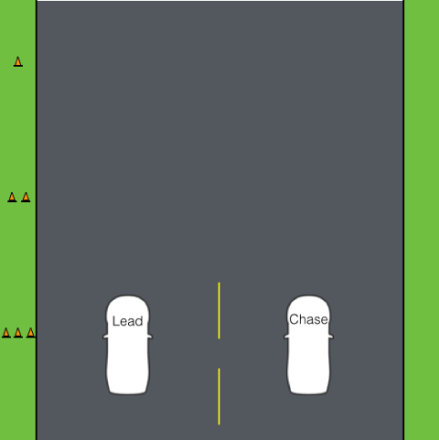

- SINGLE FILE - The chase driver can also choose to initiate behind the lead driver. In this case, the chase driver can remain in the same lane as the lead driver with as much proximity as the chase driver can achieve while staying behind the lead car. The lead driver has the full width of the lead car lane to initiate in any manner desired, as the chase car must stay behind the lead car until the lead car has initiated.

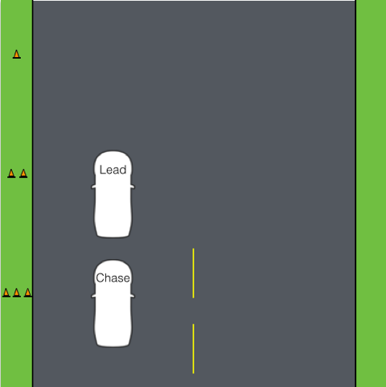

Violations of side by side or single file initiations may result in a restart or a point deduction from the judges. On some tracks the judges may decide to enforce only one initiation procedure. In such cases, this will be clearly communicated at the first drivers briefing.

  - TANDEM COLLISIONS AND CONTACT

Car contact in drifting is something that is accepted as part of the sport, however, collisions of cars while in head-to-head battle requires specific rulings and guidelines as follows:

    - LEAD CAR

If the lead car loses drift, goes off line or unnecessarily reduces speed in tandem and the chase car hits the lead car, the lead car may be deemed at fault for the collision.

    - CHASE CAR

If a Chase driver has a collision with a lead driver while they are fulfilling their lead driver goals, then the Chase driver will be deemed at fault.

    - DAMAGE DUE TO COLLISION

Once a collision has occurred, the Judges will ascertain fault. In some cases, damage sustained to the cars may require time to repair. Only the driver not at fault may request up to 10 minutes to repair their car.

    - RUN 1 COLLISIONS

If a car cannot be repaired after a collision and was deemed not at fault during the incident, the Chief Scrutineer and/or Technical Delegate will verify that indeed the car is not repairable in time for the second run of that battle and pass the information to the judges, who will declare that driver the winner of the battle. The driver will receive points for winning that battle. However, because the winning driver was unable to finish two laps of the battle, he will not move on in competition.

If the case above occurs in the final battle, the Clerk of the Course and/or Race Director have the right to permit additional time for repairs up to a maximum total of 20 minutes, in order to allow the Competition to be completed.

If both the lead car and the chase car wreck on the first run of the battle and are unable to continue due to excessive damage, with no driver deemed at fault (i.e. both driver's wreck independently of each other), the winner is determined based on the higher qualifying position.

    - RUN 2 COLLISIONS

If a collision occurs on Run 2 of a battle, the judges will deem fault and then default back to Run 1 to judge the outcome of the battle.

If both the lead car and the chase car wreck on the second run of the battle and are unable to continue due to excessive damage, with no driver deemed at fault (i.e. both driver's wreck independently of each other), the winner is determined based on the scoring of the first run of that battle. In case of even scoring, the winner of battle will be determined based on the higher qualifying position.

Should the cars have contact, that may or may have not affected either driver or may have not been either drivers fault, the Chief Scrutineer and/or Technical Delegate may need to inspect both cars for safety reasons and determine as to whether or not the car(s) remain safe and fit for continued competition.

In the above scenario, if the result leaves either driver with a tire puncture or wheel damage, the Chief Scrutineer and/or Technical Delegate may request that both drivers change their tires and/or wheels in order to ensure that one driver does not receive an advantage over the other driver.

  - CAR SERVICE DURING TANDEM

Competition cars cannot be serviced between the first and second runs of a tandem battle. This includes tire changes, tire pressure adjustments, suspension adjustments, and fuelling.

  - TANDEM REPLAYS AND TELEMETRY

When such technology is available, a video replay should be shown to the Judges after each battle run. An event’s timetable should be created to accommodate this within its schedule.

All judging is done from the designated judging stand, which should be placed in a location so as to give the maximum view across the course. If a clipping point is not visible from the judging stand, an additional system must be available for that point. This could be something as simple as a marshal with a flag to communicate if a clip has been made, or a technological solution such as video or telemetry.

External data or video is not admissible in the evaluation of a protest.

Should telemetry be used, the organisers will have the right to install equipment on each car as required. Any refusal to allow such technology to be installed will result in that competitor not being permitted to take part in the competition. In the event that on-board telemetry is used, it will only be considered as a tool to assist the Judges with scoring and the final decision will always remain with the Judges.

- COMPETITION TIMEOUT

To maintain safety in the competition, teams may request a Competition Timeout in order to perform any necessary repairs. Competition Timeout’s are not to be used for strategic purposes.

A competition timeout is limited to five (5) minutes and each competitor can only request one (1) competition timeout per event, unless stated otherwise in the event regulations. A competition timeout may not be requested during the practice or qualifying sections of an event.

When a competition timeout is requested, no team member or driver may perform any repairs on the car until the start of the competition timeout is indicated by an official.

Once the competition timeout is started, all performed repairs must be completed within the allocated five (5) minutes and the car must be ready for competition at the end of the five (5) minutes. An official may request to inspect the car for compliance and safety after conclusion of the competition timeout. Competitors who fail to make the necessary repairs within the allocated five (5) minutes, will forfeit the run to the opposing driver.

Only the designated team representative will be permitted to request the Competition Timeout. The competition timeout can only be requested from the Chief Scrutineer or Technical Delegate, although in certain circumstances, the Clerk of the course and/or Race Director may grant a Competition Timeout after consulting with the Chief Scrutineer or Technical Delegate.

Tire changes will not be permitted during Competition Timeout. Tires are required to last for both battle runs. In the event that a de-beading or rim/tire damage has occurred due to a collision, the Chief Scrutineer or Technical Delegate can permit a tire change.

Competition Time outs are for car repairs, no tire pressure or suspension setting adjustments etc. are permitted.

Competition Timeout repairs must be completed in the hot pit. Cars are not permitted to go to the main pit or paddock for a Competition Timeout, unless specifically noted otherwise in the drivers briefings.

- Tandem Battles start procedure

Prior to the start of each tandem battle run, the Clerk of the Course and/or Race Director will ensure that the track is ready and that all officials are ready for the beginning of the runs.

  - Before the first run of a tandem battles

The steps to be followed in order to start a tandem battle are:
- Officials confirms to the Clerk of the course and /or Race director that they are ready for the next battle;
- Clerk of the Course and/or Race Director declares that the track is ready for competition;
- Competition Relation Officer (CRO) calls competitors to burn out zone. Competitor with higher qualification result to be called first.

If a Driver is not ready to come to the designated burnout area when called by the CRO due to necessary repairs to be carried out, the Competitor representative must declare the need for a Competition Timeout to the Chief Scrutineer or the Technical Delegate, in accordance with Article 20.

  - Between tandem battle runs

After the first run of the battle, both Drivers must return to the start line immediately. When Drivers are at the start line, the same steps as outline in Article 21.1 must be followed in order to start the Second tandem.

If a Driver is not able to return to the start line immediately because necessary repairs must be carried out, the Competitor representative must declare the need for a Competition Timeout to the Chief Scrutineer or the Technical Delegate, in accordance with Article 20.

The second Driver must remain at the start line for the duration of his opponent’s Competition Timeout.

- Competition classification

At the end of the Tandem Competition, the winner of the final battle will be ranked in first place of the overall event. The losing finalist will be ranked in second position.
If there is a specific battle for third place, the winner of that battle will be ranked in third place of the event, with the loser in fourth place. If there is no specific battle for third place, the two losing drivers from the round of four (Semi-Finals) will be assigned to third and fourth placed overall in accordance with who placed higher in the ranking of qualifying.
The four losing drivers from the round of eight (Quarterfinals) will be assigned from fifth to eighth places overall in accordance with who placed higher in the ranking of qualifying.
The same procedure will thus be assigned for all further Tandem battle rounds (Round of sixteen, round of thirty-two, etc.) to assign the final positions in the overall results.
Those who failed to progress beyond qualifying will appear in the order that they were ranked in the qualifying results.
Any driver who fails to record a score in qualifying should appear on the final results as “Not Classified” (NC)

- COMPETITION POINT SYSTEM

In the event that the competition forms a single round of a Championship, Cup, Series or Trophy, it is recommended that the following Championship points allocation is used, dependent on the format of event:

  - TOP 32

Qualification scoring:

Battle results scoring:
Position | 1 | 2 | 3 | 4 | 5 - 8 | 9 - 16 | 17 - 32
Points | 100 | 80 | 70 | 60 | 48 | 32 | 16

  - TOP 24

Qualification scoring:

Battle results scoring:
Position | 1 | 2 | 3 | 4 | 5 - 8 | 9 - 16 | 17 - 24
Points | 100 | 80 | 70 | 60 | 48 | 32 | 16

  - TOP 16

Qualification scoring:

Battle results scoring:
Position | 1 | 2 | 3 | 4 | 5 - 8 | 9 - 16
Points | 100 | 80 | 70 | 60 | 40 | 20

  - END OF SEASON TIE BREAKERS

At the end of a Championship, Cup, Series or Trophy, should multiple drivers be tied on points, the higher place should be awarded to the competitor who was awarded the larger number of higher results across the season. For example, if Driver A has scored a 2nd, a 5th and a 10th across the season and is tied on points with Driver B who scored 3rd, 3rd and 9th, Driver A should be ranked higher due to his 2nd place being higher than any result scored by Driver B.

If a tie still occurs in the points standings, the tie breaker will be based on who finished in a higher position in the most recent event in which both drivers competed.

PROTESTS AND APPEALS

- Protest

Protests are expected to be well founded, reasonable and based on sound evidence.

A protest against an entry, driver or a car’s eligibility may be made at any time. Protests against telemetry and judges (who are considered as a Judge of Fact) decisions are not permitted.

External data or video are not permissible in the evaluation of a protest, except in cases when they have been requested by the Stewards.

  - FILING A PROTEST

Only the driver or Competitor Representative have the right to protest. Should a protest be made against multiple drivers, they must be filed and considered individually, unless the specific incident involved both at the same time.

Every protest shall be made in writing and must specify which part of the Sporting Regulations, Technical Regulations or applicable Sporting Code that is alleged to have been violated.

Protests must be in writing and signed, accompanied by the appropriate fee and submitted within the permitted timeframe to the Clerk of the Course or his representative. Failure to correctly adhere to these procedures will lead to the protest being denied.

  - PROTEST FEE

The Protest fee is €250 (or the equivalent amount in local currency) per occasion, unless specifically stated otherwise in the Competition Sporting Regulations.

  - REVIEWING PROTESTS

The Stewards will review all protests received and shall render a decision as soon as possible. At the end of an event, the podium ceremony will be permitted to proceed based on the provisional results, regardless of whether there is still an ongoing Stewards enquiry that may affect the final results.

If a protest is rejected, the protest fee will be forfeited.

If a party is not satisfied with the results of a Stewards Decision, they are reminded of their right to appeal to the applicable Court of Appeal.

- APPEALS

Appeals shall be made in accordance with the applicable National Sporting Code or FIA International Sporting Code. Any appeal must be accompanied by a fee of €1000.

GENERAL Code of Conduct and Behavior

- Disclaimer

Participants in the sporting event and accredited persons, by participating in the event, waive all rights to claim from the Organizing Committee or its respective officials, in any way for damages incurred in connection with the sports event.

- MEDIA Accreditation

Competitors or other individuals who intend to take pictures in any form for commercial purposes during a sports event and wish to enter areas outside the generally accessible spectator’s zones must register with the Organisers to obtain the appropriate accreditation. The accreditation granted sets out the safety rules of the accredited person's behaviour and clarifies the criteria for the use of photos and video material. In the application for accreditation, the applicant shall provide the necessary personal data and the specification of the medium for which the record is made. The organizer reserves the right to obtain copies of all material acquired during the duration of the competition as well as the right to use it. Violation of the accreditation conditions may result in the exclusion of the accredited person from the competition.

- Code of Conduct and Behavior

It is strictly forbidden to drive in the event paddock or service roads at speeds higher than 20km/h.

All Drivers are strictly bound by the Alcohol and Proscribed Substances policies of both their host nation and the applicable Sporting Codes. If a Driver is suspected of driving under the influence, he may be requested to perform appropriate tests. The organizer reserves the right to execute breath test of any competitor at any time without prior notice and at his own expense. Refusal to perform a breath test results in exclusion from the competition.

Any prescribed medicines used by the driver must be stated by the driver at the time of registration, and accompanied by a Therapeutic Use Exemption (TUE), if necessary.

Between the hours of 22:00 and 07:00 during events, it is mandatory for all Competitors to respect noise restrictions.

The Code of Conduct is binding for all competitors during the competition, as well as any related promotional activities before or after the event. The driver is responsible for the behaviour and actions of all team personnel and guests.

Failure to adhere to any of these rules will result in the Competitor being reported to the Stewards, and possibly sanctioned.

APPENDIX 1 – BRACKET TEMPLATES

TOP32 Bracket

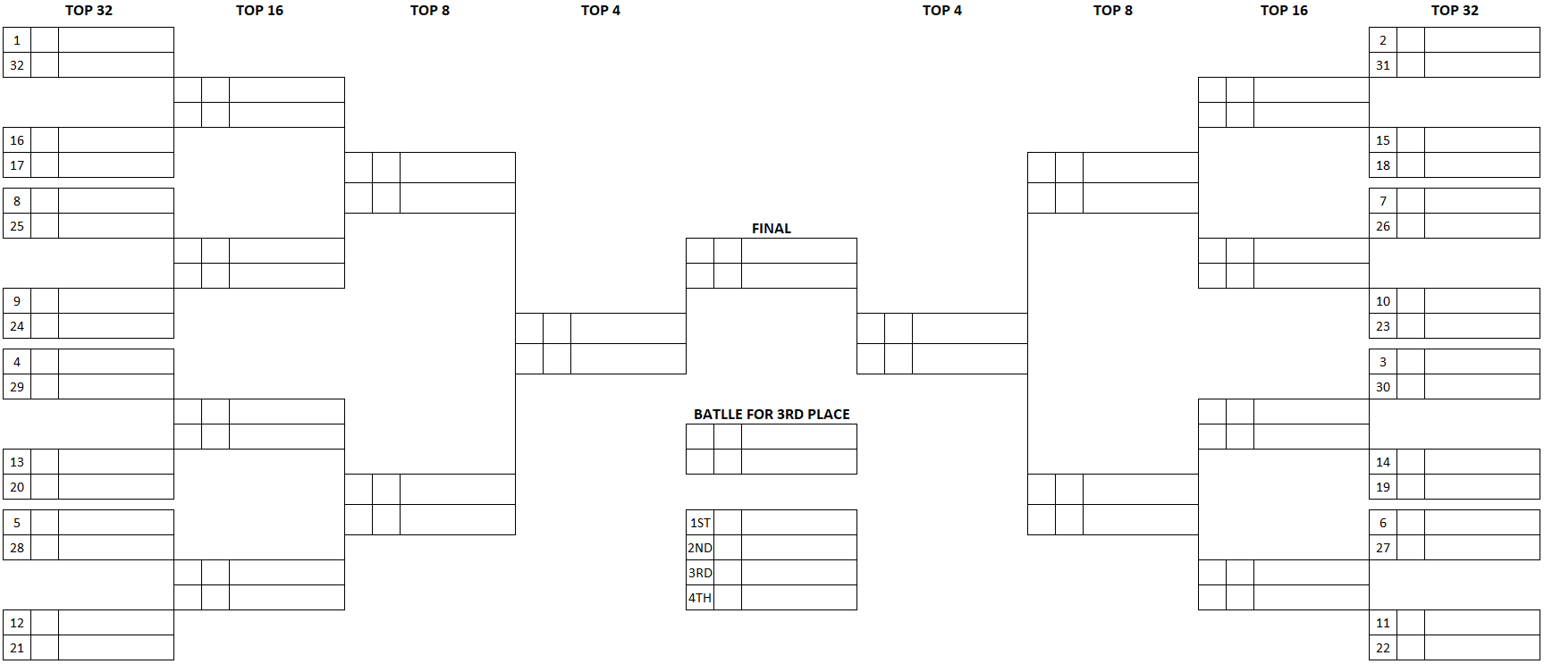

TOP 24 Bracket

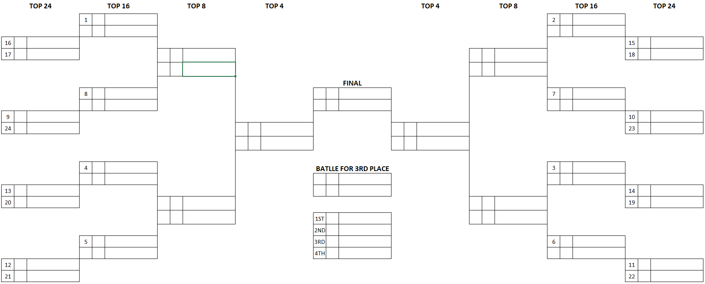

TOP 16 Bracket
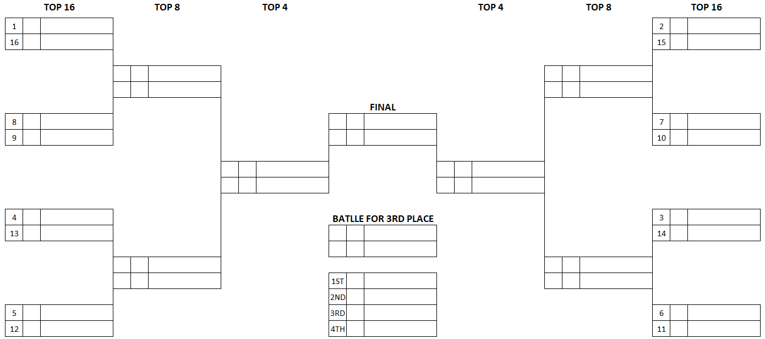

APPENDIX 2 – GLOSSARY OF TERMS

Angle | The difference between the course direction and the direction in which the car is pointing.
Bobble | When a car is in a sustained drift and there is a slight loss or increase in angle, followed quickly by a return to the initial position.
Briefing | A time when all of the drivers competing in an event must convene at one location to receive vital safety, competition, judging and scheduling information pertinent to the event in question. Briefings are mandatory and must be attended by the driver and one team member, with the driver being fully suited.
Burn-out zone | A designated safe area near to the start line where the drivers are allowed to warm-up their tyres by spinning its wheels.
Bye Run | A Bye Run is a non-judged qualifying run to prove that the mechanical condition of the car is ready for competition.
Chaseable Lead | A chaseable lead run is a run that gives the chase driver a fair chance to fulfil their responsibilities. A chaseable lead involves the following:  1. The lead driver maintains the dictated pace throughout the course.  2. The lead driver generally adheres to the Decel map,  3. The lead driver fills the majority of the outside zones and hits the inside clipping points.  4. The lead driver dictates and expresses control throughout the entire course.  Please note that a chaseable lead is not only required in tandem competition, but also during each driver’s qualifying runs. Failing to do the aforementioned may result in judging penalties.
Chaser | The car that follows at the beginning of a tandem battle.
Chicane | Is an offset in the lead car’s lane outlined with cones to make it visible to all drivers. The chicane is in place to slow the lead driver down off the line and allow the chase driver to maintain proximity down the straight away leading up to initiation.
Collision | Is defined as when a car touches another car and/or part of the course and is interrupted in line and angle.
Commitment | How consistent a driver can be while negotiating the course in terms of throttle application, maintaining pace and using momentum to fill outside zones and touch & go areas. Commitment also refers to the level of confidence and dedication displayed by the driver when approaching course edges and course barriers, keeping in mind the use of throttle, pace and momentum mentioned above.
Competition Relation Officer (CRO) | The Competition Relation Officer is the person in charge of calling the drivers in the burn-out zone according to the start list. He is also making the link with the technical delegate and the starting line marshal.
Contact | Is defined as when a car touches another vehicle and/or part of the course and generally stays uninterrupted in line and angle.
Correction | When a driver uses the hand brake to adjust the angle or the line of their car when either are poor.
Drifting | Drifting is a driving technique in which a driver breaks the rear wheels out of a gripping position and counter-steers the car around a course marked by clipping points, clipping zones and touch & go areas. Judges dictate the desired line throughout the course, highlight specific areas of importance and determine the score each driver earns as they attempt to qualify for the main competition. Once drivers have earned their position in the competition bracket, drivers compete against each other two at a time on the same course. Judges determine the winner and which driver moves onto the next bracket.
Fluidity | Refers to the rotation of the car on its own axis during initiation and transitions between turns. Ideally the rotations should be quick, smooth and accurate. Once at angle, the car should remain settled and in control until the next transition.
Hot Pit | A Hot pit is a designated area near to the startline where work may be carried out on cars during the Battle section of a competition.
Initiation | The act of breaking rear wheel traction while increasing the angle of the car in relation to its direction of travel, while adding counter-steer to maintain the angle attained. Techniques include clutch kicking, pulling the hand brake, weight transfer, and a combination of two or more of these techniques.
Inside Clipping Point | A point on the course, generally on the inside of a corner, that has been clearly marked and is used as a reference for both the line and angle judges to judge competency in their respective criteria. Drivers are required to pass by the cone with their front bumper as closely as possible to receive a score from the line judge, while the angle judge will score each car’s angle as it passes by each of the clipping points on-course.
Judges | There are 3 Judges per event. Each judge is responsible for one aspect of the judging criteria (line, angle or style) during qualifying; these responsibilities rotate among the 3 judges throughout the season. The judges are responsible for relaying the desired line, angle and style requirements to the drivers during the driver’s briefings, which they then use to dissect each qualifying run. During tandem battles, they watch both lead and chase drivers compete against one another to determine a winner.
Latest initiation point | Is the point at which the car must be sideways. It is marked by single standing cone in the “3, 2, 1” cone sequence.
Lead | The car that is leading at the beginning of a tandem battle.
Line | The ideal trajectory to be driven by the competitors throughout the course as described by the judges during the driver’s briefings. The ideal line will be indicated with clipping points, clipping zones and touch & go areas throughout the course.
One More Time (OMT) | Occurs due to lack of a majority vote from the judges. The tandem battle that received the OMT vote from the must run the tandem battle again until the result is a majority vote decision. One More Time (OMT) calls are not intended for poorly executed tandem battles. The judges reserve the right to make a judgment call on battles that contain a multiple variety of mistakes and/or deductions and declare a winner.
Opposite Drift | When a car attains angle in the opposite direction of what is stipulated for that area of the course.
Outside Zone | An area, generally on the outside of the course along the edge of the pavement or along a wall or barrier, that has been clearly marked and is used as a reference for both the line and angle judges to judge car in their respective criteria. Drivers are required to place the rear of their vehicle in between the cones for the length of the zone while in drift to receive a score from the line judge, while the angle judge will score each car’s angle as it passes by each of the clipping zones on- course.
Pass | When a chase vehicle goes by a lead car during a tandem battle. A pass is only considered legal if it was performed at a clipping point, the lead car was offline and if the chase car.
Transition | The act of rotating a car from a high degree of angle in one direction to a high degree of angle in the opposite direction without stopping the rotation at any point in between.
Unchaseable Lead | An unchaseable lead run does not give the chase driver a fair chance to fulfil their responsibilities. An unchaseable lead run may involve some or all the following:  1. The lead driver varies pace unpredictably or not as described on the course.  2. The lead driver does not adhere to the Decel map, whether due to driver error or car malfunction or trying to get away from the chase driver by cheating one or more of the lead driver responsibilities.  3. The lead driver missing the majority of the outside zones and/or inside clipping points.  4. The lead driver is out of control or erratic throughout the course.  Please note that a run can be deemed “unchaseable” in qualifying just as it can in tandem competition.  Additionally, an Unchaseable lead can be more consequential to a lead driver in tandem if the chase driver is within relative proximity and affects (or seemingly affects) the chase driver.  An Unchaseable lead is always a negative for the lead driver, but the degree to which the judges apply judging penalties can be/or will be dictated by the actions that affect the chase driver

